Antonio Nuić
Chairperson
DHFR Croatian Film Directors’ Guild
Nova Ves 18
1000 Zagreb, Croatia

November 26th ,2019

Dear colleagues,

The Israeli Directors' Guild hereby extends its full support of the Croatian filmmakers’ campaign I’D LIKE TO WATCH THAT – HRT SAYS – NYET! initiated in July 2019, raising the alarm at public service broadcaster HRT’s failure to fulfill its obligations regarding the promotion of European audiovisual works.

Urgent action is needed by the Croatian authorities to address a situation which has reportedly significantly degraded over the last few years and reached a critical point in terms of freedom of speech, artistic freedom and cultural diversity.

We stand by you in these difficult times.

Sincerely yours,

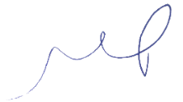
Limor Pinhasov
Chairwoman

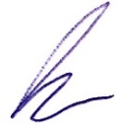
Roei Elba
Chief Executive Officer

